Resilience Engineering Framework Integration in Off-Grid Renewable Energy Systems

**AUTHORS**

#NameSurname

#Dept

#Uni

#City,Country

#Contact

Pier Luca Anania

Sapienza University of Rome, (or TS?)

Rome, Italy

p.l.anania@gmail.com

**ABSTRACT**

To Be Written

1. **Introduction**

More than 1.4 billion people worldwide do not have access to electricity. Roughly 85% of these people live in rural areas and a large proportion live in Africa [1]. To date many utilities and governments have been unable to meet the energy needs of rural areas, as the focus has often been on meeting the demand of major industries or highly-populated urban areas such as Nigeria's area in Western Africa or the area around Lake Victoria on the Ugandan side. [2]

In the contemporary landscape of energy systems, microgrids have emerged as pivotal infrastructures, particularly in remote or off-grid areas, offering a decentralized and sustainable solution to electricity provision. However, ensuring the reliable operation of microgrids amidst diverse challenges poses a significant concern. Anomalies, ranging from equipment malfunctions to extreme weather events, can disrupt normal operations, leading to service interruptions and potential safety hazards. Addressing these challenges necessitates not only robust anomaly detection mechanisms but also a holistic approach that integrates principles of resilience engineering.

An integrated approach utilizing the theoretical and practical principles of Resilience Engineering is crucial in a world of constant change, whether we are talking about phenomena relating to climate change, geopolitical instabilities or simply the reliability of a more or less complex energy system.

Being able to rely on continuous service is crucial in contexts of full electrification (think of the need to service critical infrastructure) as well as in contexts of rural electrification. In a community where the energy supply is tied to a single source and its life and economy depend on it, it is more necessary than ever to define, from the earliest stages, a system capable of overcoming technical, operational and community shortcomings. [3]

The primary objective of this work is to develop a comprehensive understanding of how resilience engineering concepts can inform and improve fault detection strategies by leveraging insights from resilience engineering literature and methodologies. This study aims to enhance the robustness and adaptability of anomaly detection algorithms, thereby bolstering the overall resilience of microgrid operations.

Through the analysis of an Open-Source dataset concerning a PV production plant, an Exploratory Data Analysis and the implementation of a Fault Detection algorithm will be carried out in order to highlight critical points in the system.

The aim is to structure a multidisciplinary and multiobjective approach in which the resilience engineering framework is applied to a photovoltaic energy production system. By fostering a deeper understanding of the interplay between resilience engineering and microgrid operations, this research endeavors to inform future strategies for enhancing the reliability and sustainability of decentralized energy systems.

1. **Relevance of Resilience Engineering in Microgrids**

* 1. #inserisci titolo sullo scopo della Res.Eng. -> Hayley(?)

Resilience engineering, a paradigm rooted in the fields of safety and systems engineering, emphasizes the ability of systems to adapt and recover from disruptions while maintaining essential functions. By shifting the focus from preventing failures to managing and mitigating their consequences, resilience engineering offers a promising framework for enhancing the performance and reliability of complex systems like microgrids.

The increasing demand for electricity and the need for sustainable energy sources have led to the development of various decentralized energy systems, including microgrids. However, these microgrids are often subject to disturbances and failures, which can have significant impacts on the communities they serve. Resilience engineering, which focuses on the ability of a system to adapt and recover from disturbances, is therefore highly relevant in the context of microgrids. This thesis will discuss the relevance of resilience engineering in microgrids, highlighting its importance in ensuring the sustainability and reliability of these energy systems.

Resilience engineering is a proactive approach to engineering that focuses on the ability of a system to anticipate, respond to, and recover from disturbances and failures [4]. It recognizes that disturbances are inevitable and that the goal is not to prevent them but to manage them in a way that minimizes their impact.

Microgrids, on the other hand, are small-scale, decentralized electricity distribution systems that serve a limited geographical area. They are often used in remote or rural areas where there is no access to the centralized grid. Microgrids can be powered by various energy sources, including fossil fuels, renewable energy, or a combination of both. [5]

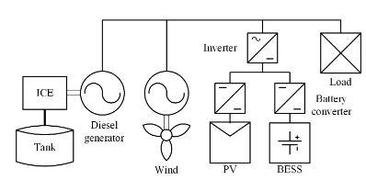

**Fig.1:** The topology of the microgrid [5]

The relevance of resilience engineering in microgrids can be seen in several ways:

* *Improved System Reliability*: Microgrids are often the sole source of electricity for the communities they serve. Any disruption in the supply of electricity can have significant impacts on the community's social and economic well-being. Resilience engineering can help improve the reliability of microgrids by ensuring that they can withstand and recover from disturbances quickly.
* *Cost-Effective*: Resilience engineering focuses on managing disturbances rather than preventing them. This approach can be more cost-effective than trying to prevent all disturbances, which can be expensive and often not feasible. By managing disturbances effectively, microgrids can reduce the need for costly repairs and replacements.
* *Increased Sustainability*: Resilience engineering can help increase the sustainability of microgrids by ensuring that they can adapt to changing conditions. For example, microgrids that are designed with resilience engineering principles can better adapt to changes in energy demand, climate change, and technological advancements.
* *Improved Safety*: Microgrids that are designed with resilience engineering principles can be safer for both the operators and the communities they serve. By anticipating and managing disturbances, microgrids can reduce the risk of accidents and injuries.

Resilience engineering is highly relevant in the context of microgrids. It can help improve the reliability, cost-effectiveness, sustainability, and safety of these energy systems. By focusing on the ability of microgrids to anticipate, respond to, and recover from disturbances, resilience engineering can ensure that microgrids can continue to provide essential electricity services to the communities they serve, even in the face of challenges and uncertainties. As the demand for decentralized energy systems continues to grow, the importance of resilience engineering in microgrids cannot be overstated.

## Performance Risk Analysis

It is important to evaluate the ability of the energy system to meet the defined extended outage performance criteria. This is typically done using a risk-informed performance assessment. [6] Described in this section are performance parameters used to defined performance risk in a way that has been valuable to previous analyses. However, this definition of performance risk may need to be modified based on the specifics of the microgrid being considered to best address the true performance of that microgrid. For example, the equations below reference percent of critical buildings served. For certain applications, the percent of people receiving a critical service (e.g., clean water, cell phone signal, etc.) may be a better metric.

We have generally based energy system performance risk assessment on how well the energy system can meet critical infrastructure functions and services during a given power outage. Based on this approach, we define the performance risk for a given outage as a function of the critical buildings and loads served and the length of time they can be met by the energy system. The performance risk, , defined as:

(2)

Where:

Percent of critical building served – critical buildings with backup power systems. If few buildings are served, then consequences and risk will be high.

Percent of critical loads served – weights serving the defined critical loads for the critical services and buildings. If minimal loads are covered, the consequences and risks will be high.

Reliability of generation – weights the maintenance of backup generators. Low maintenance lowers reliability and the risks will be high.

Ration of generator fuel availability versus outage duration. If the generator fuel tank is small, and/or the ability to refuel the generator is low, then the risks can increase for longer power outages, unless renewable or other energy resources are available.

Based on customer outage evaluations for some major natural disasters, it has been found that typically when backup power systems can meet 85% or more of the critical buildings and loads served for 85% or more of the outage duration, the overall power system can adequately provide power to support critical community services and functions without significantly impacting overall public health and safety. For energy systems that meet less than 70% of the critical buildings and loads served for less than 70% of the outage duration, the community health and safety become increasingly stressed. Therefore, in general we have quantified energy system performance risk notionally as:

Low Performance Risk –

Medium Performance Risk –

High Performance Risk –

It has been evaluated improved resilience as both the reduced impact of the event and the reduced recovery time to return to normal operation after the event. Specifically, the system impact () of the event is the time integral of the “typical” system performance () minus the actual system performance ():

(3)

Similarly, the total recovery effort (is the time integral of the recovery effort:

(4)

## Energy Resilience

Although there are various definitions of system resilience in the literature, the resilience of modern composite energy systems requires more research, especially at the community level including the new generation of district and smart energy systems. [14]

The resilience of energy systems can be defined based on the characteristics of these systems and the nature of the disruptive events (e.g. a system can be resilient to a heatwave but not to an ice storm). For example, DOE defines the resilience of the electrical grid as “the ability of a system or its components to adapt to changing conditions and withstand and rapidly recover from disruptions” (opposed to “security” which is to “withstand attacks”). There are six components of resilience, namely “the ability of an entity - asset, organisation, community, region - to anticipate, resist, absorb, respond to, adapt to, and recover from a disturbance” [5].

A sustainable energy system (i.e. satisfying four dimensions of availability, accessibility, affordability and acceptability) should be comprised of preparation, absorption, recovery and adaptation abilities. In order to provide more resilience to increasingly complex and interconnected (energy) systems and tackle the uncertainties, costs, and challenges in the nature of these systems subject to extreme events need for clear definitions, metrics, and evaluation methods for resilience development.

Furthermore, the performance criteria that include these metrics need to be formulated more in probabilistic terms to account for risks and likelihoods of disruption. In the Sandia National Laboratory report for the 2015 Quadrennial Energy Review, the authors note that resilience metrics should consider threat, likelihood, and consequence and thus because common reliability metrics do not possess these attributes, they are “orthogonal in purpose and discrimination capability to resilience metrics” [6]. Resilience metrics encompass all disruptions that have different levels of uncertainties, with particular attentiveness to high-impact, low-frequency events [7]. But in addressing system resilience, both qualitative and quantitative performance criteria and metrics are required.

Quantitative, time-dependent resilience metrics are introduced for power system resilience to measure how fast and how low the resilience drops, how long the system remains in the degraded state, and how quickly it recovers.

Although these metrics from the literature are not focused solely on energy resilience, they can be tailored for community-level system energy resilience evaluation. A summary of resilience metrics, and qualitative and quantitative resilience evaluation methods, is given in Table 1.

|  |  |  |
| --- | --- | --- |
| Type | Metrics | Evaluation Method |
| Qualitative Evaluation | Resiliency indices  Functional redundancy | Checklists and questionnaires  Matrix scoring system  Analytic hierarchy process (AHP)  Energy flow-based system performance modelling methods under different scenarios  Graph-theory and probabilistic method  Spatial power outage duration model  Benefit-cost analysis |
| Quantitative Evaluation | Time-dependent metrics for the resilience of power networks based on slopes and area of resilience trapezoid  Probability distribution of economics costs  Area under the curve between targeted performance and real performance  Ratio of the area between real performance curve to targeted performance curve during a year  Probability of network performing its intended functions  Time to restoration following a failure  Performance-based resilience index |

Table 1: Resilience metrics and evaluation methods

It can be seen that although there are several metrics and evaluation methods for specific events, there is no consensus on method or metrics for measuring energy resilience, and defining the mitigation and enhancement strategies, especially during the energy master planning. Various aspects of resilience are considered individually and with a narrow focus which restricts opportunities in other dimensions of resilience e.g. infrastructure, operational and social. Although these qualitative and quantitative methods and metrics can lead to measurement of a particular resilience measure, they do not provide a consistent approach for measuring the overall resilience of the system for the purpose of energy resilience planning.

In energy master planning process, prescriptive and performance approaches (and associated metrics) can be employed in resilience assessment and enhancement. Prescriptive-based resilience approach considers the acceptable or required resilience solutions and limits, while the performance-based resilience approaches use quantifiable metrics to measure the resilience of the system performance. The performance-based approach includes the system-based or attribute-based metrics such as level of redundancy, number of backup transformers and number of highly trained staff. Resilience planning for critical infrastructure should be based on the critical services required to support the community rather than the physical condition of infrastructure only [14].

The system performance metrics can be divided into the consequence-based (e.g. environmental, social, economic and the national security) metrics and service-based (e.g. electricity, heating, cooling and water) metrics. Sometimes the resilience performance of each service should be measured in each critical nodes of the energy system. Each of these nodes might have different resilience requirements. The performance-based metrics can be employed in energy master planning to estimate the impacts of the system disruption or unusual system service performance in terms of environmental, social and economic consequences. These consequences are sometimes inter-related for instance, assessing the social impacts might be required to be able to assess the economic impacts.

# Hybrid REF-Fault Detection Implementation

The implementation of the algorithm was carried out on an OpenSource dataset of data from two PV plants. There are two different datasets from these plants. The first one concerns information on the power output of the plant with information:

* Date and time for each observation. Observations recorded at 15 minute intervals.
* Plant ID number
* Inverter ID alpha-numeric codification
* Amount of DC power generated by the inverter in this 15 minute interval.
* Amount of AC power generated by the inverter in this 15 minute interval.
* Total yield for the inverter till that point in time.

The second has information on the meteorological data of the individual plant, although they are close together, in order to be resilient to sensor failures. The information it concerns is:

* Date and time for each observation. Observations recorded at 15 minute intervals.
* Plant ID number
* Ambient temperature at the plant
* Module temperature attached to the sensor panel.
* Amount of irradiation for the 15-minute interval.

## Methodology

La metodologia seguita si basa sullo studio delle performance dell’inverter al fine di valutare eventuali failure nella conversione ovvero anomalie nel sistema. Essendo l’elemento tramite cui fluisce il flusso di potenza è considerabile come il collo di bottiglia per ogni considerazione dal punto di vista della resilienza del sistema. Dopo una fase iniziale di tecniche di Data Collection tramite la sensorizzazione dell’impianto, Data Preprocessing [9] e Exploratory Data Analysis [10] si entra nella subroutine del Condition Monitoring. Qui come regola di filtraggio sugli inverter è applicato un controllo sulla potenza in output:

(2)

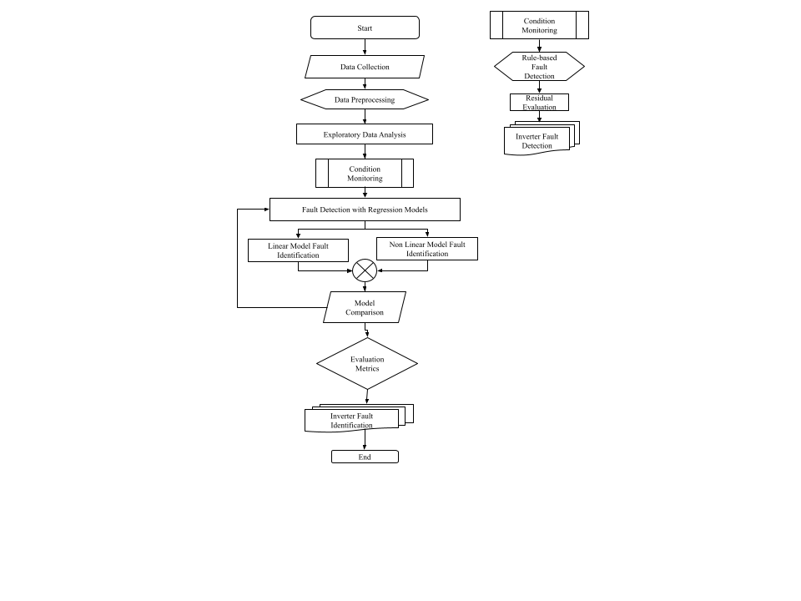

Fig.2: Hybrid linear – nonlinear fault identification algorithm

**CONCLUSION**

**REFERENCES**

### [1] International Energy Agency (IEA), (2010) Energy Access: How to make modern energy access universal.

### [2] Knowledge Note of CIF Climate Investment Fund, (2014), Increasing Rural Energy Access through Mini-Grids

### [3] Saeid Charani Shandiz, Greg Foliente, Behzad Rismanchi, Amanda Wachtel, Robert F. Jeffers (2020), Resilience framework and metrics for energy master planning of communities, Energy, Volume 203

### [4] Hollnagel et al., (2006), *Resilience Engineering Concepts and Precepts*, Ashgate Edition

### [5] Fioriti, Davide & Poli, D. & Martinez, Pablo & Micangeli, Andrea. (2022). Clustering approaches to select Multiple Design Options in multi-objective optimization: an application to rural microgrids. 1-6. 10.1109/SEST53650.2022.9898440.

### [6] Sandia National Laboratories, U.S. Department of Energy (DOE) (2019). *Fundamentals of Advanced Microgrid Design*.

### [7] Vugrin ED, Castillo A, Silva-Monroy C. Resilience metrics for the electric power system: a performance-based approach. Sandia National Laboratories; 2017.

### [8] Rübbelke D, Vogele S. Short-term distributional consequences of climate change impacts on the power sector: who gains and who loses? Climatic Change 2013;116(2):191 - 206.

### [9] Hosseinzadeh, Mehdi & Azhir, Elham & Ahmed, Omed & Ghafour, Marwan & Ahmed, Sarkar & Rahmani, Amir & Vo, Bay. (2021). Data cleansing mechanisms and approaches for big data analytics: a systematic study. Journal of Ambient Intelligence and Humanized Computing. 14. 1-13. 10.1007/s12652-021-03590-2.

### [10] Mario Li Vigni, Caterina Durante and Marina Cocchi, "Chapter 3 - Exploratory Data Analysis Editor(s): Federico Marini Data Handling in Science and Technology", Elsevier, vol. 28, pp. 55-126, 2013, ISSN 0922-3487, ISBN 9780444595287.